

Gene Technology Ministers’ Meeting

ACTION PLAN 2020 – 2023

**UPDATED JUNE 2021**

In response to the Third Review (the Review) of the National Gene Technology Scheme (the Scheme), and in addition to the ongoing activities of the Legislative and Governance Forum on Gene Technology (now to be known as the Gene Technology Ministers' Meeting - GTMM*), all Australian Governments - through the GTMM - agreed to pursue an Action Plan which prioritised activities to be undertaken to update the Scheme over the 2018–2023 period.

As a result of the 2020 National Cabinet Review of COAG Councils and Ministerial Forums conducted by Mr Peter Conran AM (the Conran Review), 3 key priorities were identified for GTMM action in 2021, which are linked to related Review Recommendations.

This 2021 Action Plan update groups recommendations with closely linked implementation activities under separate work programs. It also lists those actions that have been completed for each recommendation. In some case components of the recommendations are on-going. Completed tasks have also been identified as part of the document.

This update includes:

Summary of Key Priorities for 2021

Revised Status of Recommendations

List of Review Recommendations

**Please note:** This Action Plan is a dynamic, working document. It provides a framework for Review implementation through the Gene Technology Standing Committee (GTSC), a group comprising of senior officials from each state, territory, and the Commonwealth.

# SUMMARY OF KEY PRIORITIES FOR 2021

The following diagram provides an outline of the 3 key GTMM Priorities for 2021, agreed following the National Cabinet Review of COAG Councils and Ministerial Forums conducted by Mr Peter Conran AM (Conran Review). Review implementation work programs (refer to page 3) are then idenfitied under each priority, in turn outlining the specific Review recommendations (or elements thereof) that relate to that Priority.

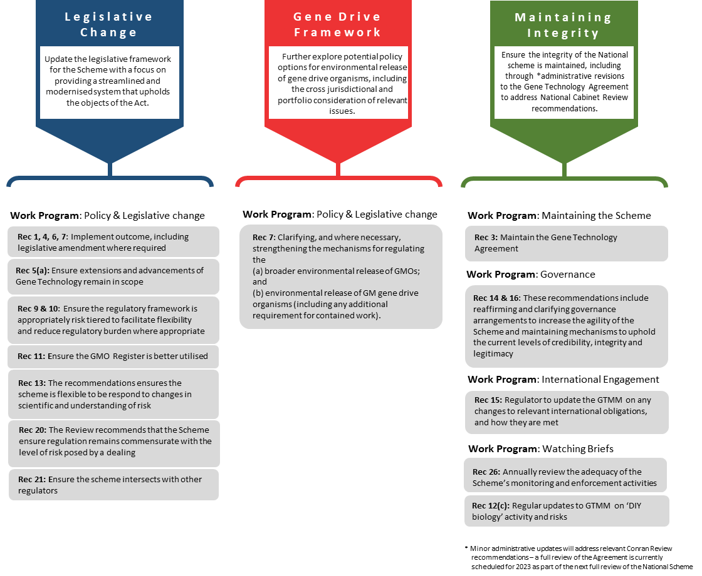

# REVISED STATUS REPORTING

Recommendations from the Third Review of the National Gene Technology Scheme

| WORK PROGRAM | THIRD REVIEW'S RECOMMENDATIONS | CURRENT STATUS |
| --- | --- | --- |
| Maintaining the Scheme | **Recommendation 2, 3, 8, 12 & 19**  These recommendations relate to issues such as maintaining the object of the Gene Technology Act, 2000 and the intergovernmental Gene Technology Agreement. Also covered are maintaining a process based trigger for the entry point for the Scheme at present, as well as work to ensure the Scheme’s monitoring and enforcement activities remain adequate. Consideration of benefits (e.g. possible economic, environmental and health benefits) should also not be introduced as an element of regulatory decision making at this time. | Completed – all necessary initiating work  **NB:** Implementation of these recommendations involves ongoing business as usual (BAU) activities, including continued monitoring of the needs of the Scheme, and governance oversight of matters impacting on the Scheme |
| Governance | **Recommendation 14 & 16**  These recommendations include reaffirming and clarifying governance arrangements to increase the agility of the Scheme and maintaining mechanisms to uphold the current levels of credibility, integrity and legitimacy. | Partially completed  Further work required to address the Conran Review  **NB:** Some elements involve ongoing BAU activities |
| Watching Briefs | **Recommendation 5(b) & 26**  These recommendations involve ensuring that any potential new risks associated with gene technology are appropriately identified and managed. | Completed – all necessary initiating work  **NB:** Some elements involve ongoing monitoring and reporting activities |
| International Engagement | **Recommendation 15**  This recommendation involves the Gene Technology Regulator continuing to engage with relevant stakeholders (both national and international) to ensure that any relevant international obligations are met | Completed – all necessary initiating work  **NB:** This recommendation involves ongoing BAU activities |
| National Consistency | **Recommendation 17 & 18**  Responsibility for implementing these recommendations fall with states and territories and involve activities associated with maintaining the integrity of the Scheme and ongoing consideration of state based moratoria. | Completed – all necessary initiating work  **NB:** This recommendation involves ongoing work, as required, to minimise the impact of different jurisdictional approaches on the integrity of the Scheme |
| Communications | **Recommendation 23, 24, 25 & 27**  These recommendations relate to activities aimed at ensuring that all stakeholders are kept informed about matters relating to gene technology, to aid public understanding and confidence in the Scheme. | Partially completed  Further work required in 2021 to aid public understanding and confidence in the Scheme  **NB:** These recommendations involve ongoing monitoring and reporting activities |
| Policy/Legislation Change | **Recommendation 1, 4, 5a, 6, 7, 9, 10, 11, 13, 20 & 21**  These recommendations all involve both administrative and legislative changes in order to update, futureproof and modernise the Scheme to ensure it is best practice, appropriately flexible and risk-based, in an environment where understanding about the science and the inherent risks is evolving. | Partially completed  Key deliverables for 2021 include:   * Consultation on a preferred regulatory model in which to implement Review recommendations * Final GTMM agreement on a preferred regulatory model * Legislative drafting to give effect to Review recommendations * Consultation on proposed legislation |
| Funding | **Recommendation 22**  This recommendation requires further consideration be given to the most appropriate funding mechanisms to support the ongoing operation of the Scheme, and to appropriate funding levels for the Gene Technology Regulator’s activities, taking into account any changes to the Scheme. | This recommendation cannot commence until a revised regulatory framework and associated legislation are finalised |

# List of Review Recommendations

## Overarching Issues

**Recommendation 1**: To build upon and futureproof the Scheme, which is highly regarded, the Review recommends:

a) the Forum progress options to update and enhance the operations of the Scheme; and

b) these options be implemented in short, medium and long-term tranches, according to an action plan to be developed by the Forum.

**Recommendation 2:** The Review recommends that the object of the Gene Technology Act 2000 be maintained.

**Recommendation 3:** The Review recommends that the Gene Technology Agreement be maintained.

## Review Theme One: Technical Issues

**Recommendation 4:** The Review recommends updating, where required, the existing definitions in the Gene Technology Act 2000 (Cth), to clarify the scope of regulation in light of ongoing technical advances. Any changes to definitions should take into account concurrent work, including relevant domestic reviews and ongoing work internationally.

**Recommendation 5:** The Review recommends that:

a) extensions and advancements of gene technology, such as synthetic biology, continue to remain within the scope of the Scheme; and

b) a watching brief on synthetic biology should be maintained, to ensure the appropriate level of regulation is applied to future applications of synthetic biology.

**Recommendation 6:** The Review recommends:

a) the definition of a genetically modified organism under the Gene Technology Act 2000 (Cth) be amended to clarify that humans are not [considered to be] GMOs; and that

b) subject to consideration, the COAG (Council of Australian Governments) Health Council might also consider whether additional regulatory oversight is needed for humans who may receive or inherit germline therapies (or other somatic therapies not within the remit of the Scheme). The COAG Health Council should also consider which regulatory (or other) body would be most appropriate to undertake such oversight.

**Recommendation 7**: The Review recommends clarifying, and where necessary strengthening, the mechanisms for regulating the:

a) broader environmental release of genetically modified organisms; and

b) environmental release of GM gene drive organisms (as well as any additional requirements for contained work).

## Review Theme Two: Regulatory Issues

**Recommendation 8**: The Review recommends that a process-based trigger be maintained as the entry point for the Scheme at the present, to allow for any potential risks associated with new technologies to be initially considered within the scope of the Scheme.

**Recommendation 9:** The Review recommends the introduction of additional risk tiering into the Scheme, to facilitate flexibility of the regulatory Scheme and ensure:

a) the level of regulation remains proportionate to risk, and protects against under regulation and over-regulation; and

b) where appropriate, there is flexibility to move organisms between categories, based on identification of new risks, a history of safe use, or other relevant factors.

**Recommendation 10**: The Review recommends reducing regulatory burden through streamlining processes and current regulatory requirements where appropriate. For example, this may include streamlining facility certifications and application processes.

**Recommendation 11**: The Review recommends that changes be made to enable the GMO Register to be more effectively utilised within the Scheme.

**Recommendation 12**: The Review recommends that, to ensure the Scheme’s current monitoring and enforcement activities remain adequate:

a) regular reviews of these activities are undertaken;

b) regulatory requirements for working with gene technologies are widely communicated and known; and

c) the scope and associated risks of ‘DIY biology’ activity continue to be monitored.

**Recommendation 13:** The Review recommends that to better respond to changes in scientific understanding and understandings of risk, consideration should be given to:

a) enabling the Gene Technology Regulator to make decisions on the applicability of regulation to any technological developments, until such time as a policy approach has been agreed; and

b) introducing elements of principles-based regulation to some parts of the Scheme, focusing on areas of the Scheme with a history of safe use.

**Recommendation 14**: The Review recommends reaffirming and clarifying governance arrangements to increase the agility of the Scheme, including more effective use of mechanisms for:

a) the Gene Technology Standing Committee to consider and recommend changes to the legislation for the Legislative and Governance Forum on Gene Technology endorsement; and

b) delegating certain activities and work programs of the Legislative and Governance Forum on Gene Technology to the Gene Technology Standing Committee.

**Recommendation 15**: The Review recommends that the Australian Government, including the Gene Technology Regulator on regulatory matters, continues to:

a) engage with appropriate international fora on matters relevant to market access and international trade; and

b) ensure that any relevant international obligations continue to be met.

## Review Theme Three: Governance Issues

**Recommendation 16**: The Review recommends maintaining current governance mechanisms to ensure that the Scheme’s current levels of credibility, integrity and legitimacy are upheld. This includes maintaining:

a) high level governance oversight provided by all states and territories through a Legislative and Governance Forum on Gene Technology;

b) the independence and credibility of the Gene Technology Regulator; and

c) robust governance processes providing oversight of advisory structures and appointments.

**Recommendation 17**: The Review recommends that states and territories continue to ensure that their gene technology Acts remain corresponding and that appropriate mechanisms are in place to update corresponding state and territory legislation following amendment of the Gene Technology Act 2000 (Cth).

**Recommendation 18**: The Review recommends that states and territories give ongoing consideration to the economic effects, value and scope of moratoria.

**Recommendation 19**: The Review recommends that consideration of benefits (e.g. potential economic, environmental and health benefits) should not be introduced as an element of regulatory decision making at this time.

**Recommendation 20:** The Review recommends that the Scheme ensures regulation remains commensurate with the level of risk posed by a dealing (see **Recommendations 9** and **10**) so that no unnecessary regulatory burdens are imposed.

**Recommendation 21**: The Review recommends clarifying the intersection between the Gene Technology Regulator, other regulators and legislation, which may include:

a) identifying opportunities to enhance communication mechanisms and linkages;

b) identifying any emerging areas where legislative or administrative changes can be made, to reduce any unnecessary duplication; and

c) adopting relevant effective mechanisms from other schemes (for example, the Therapeutic Goods Act 1989 Special Access Scheme) where they may strengthen the Scheme.

**Recommendation 22:** The Review recommends that further consideration be given to the most appropriate funding mechanisms to support the ongoing operation of the Scheme, and to appropriate funding levels for the Gene Technology Regulator’s activities, taking into account any changes to the Scheme.

## Review Theme Four: Social and Ethical Issues

**Recommendation 23:** The Review recommends that targeted communications be developed to aid public understanding and confidence in the Gene Technology Scheme and identify the most appropriate body/bodies to deliver communications materials.

**Recommendation 24:** The Review recommends that the Gene Technology Regulator continue to lead communication activities on topics related to the assessment of risk associated with gene technology.

**Recommendation 25**: The Review recommends that the Gene Technology Regulator continue to identify and manage the risks posed by, or as a result of, gene technology, and to increase transparency and understanding.

**Recommendation 26**: The Review recommends a science-based review of monitoring arrangements to ensure that any post release risks continue to be appropriately managed.

**Recommendation 27**: The Review recommends that the Gene Technology Regulator continue to make relevant information publicly available, to maintain a high level of transparency within the Scheme.